Concepts of Operating System

Assignment 2

Part A

What will the following commands do?

1.echo "Hello, World!"

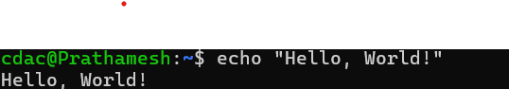

2. name="Productive"

We need to first create

**nano p1.sh**

write inside it

**name="Productive"**

**echo name**

come outside of it

bash p1

3. touch file.txt

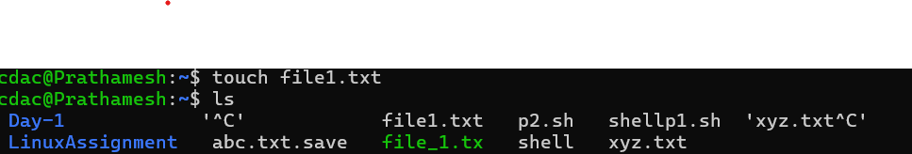

4. ls -a

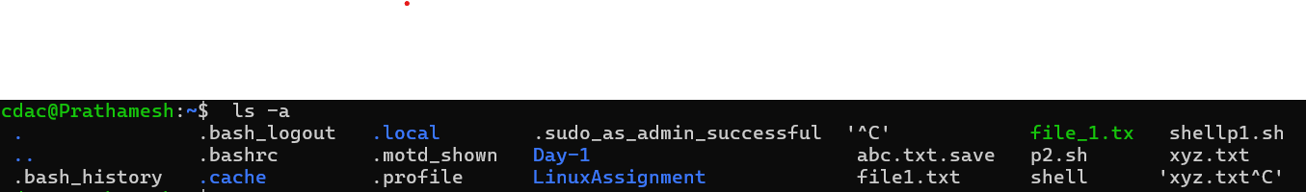

5. rm file.txt

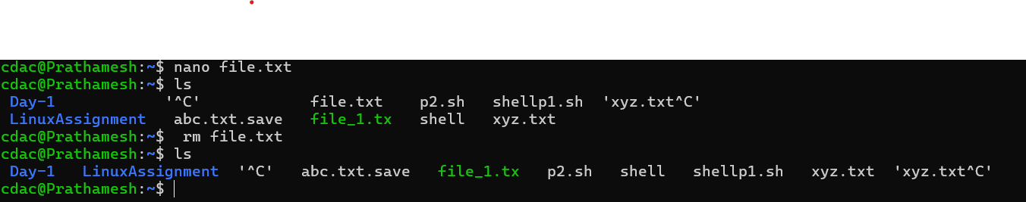

6. cp file1.txt file2.txt

Copy file1 data to file2

7. mv file.txt /path/to/directory/

To move file.txt from one directory to other directory

8. chmod 755 script.sh

It changes the file permission of script file

9. grep "pattern" file.txt

It will find pattern in file.txt

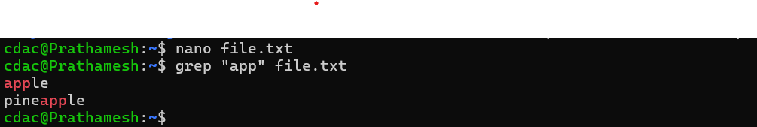

10. kill PID

It is used to terminate the program

11. mkdir mydir && cd mydir && touch file.txt && echo "Hello, World!" > file.txt && cat file.txt

Creates new directory mydir,change working directory to mydir,create file.txt inside mydir then write inside file.txt helloworld and display content of file.txt on terminal

12. ls -l | grep ".txt"

Output of first cmd passed as input to 2nd cmd,grep used to find patten

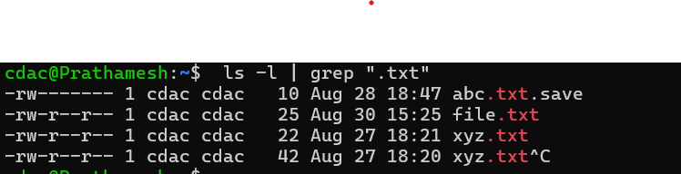

13. cat file1.txt file2.txt | sort | uniq

Concatenating file1 and file2 sorting it and then filtering out the unique values(only common)

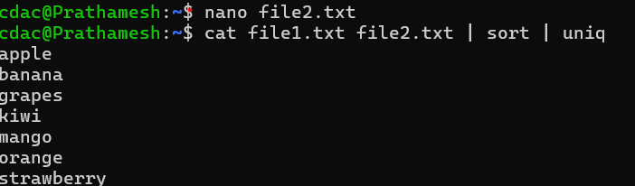

14. ls -l | grep "^d"

ls-l list out all the files and directories,grep finds all the words starting with letter ‘d’ and prints it out

15. grep -r "pattern" /path/to/directory/

Grep finds patterin in all files and directories and print it out

16. cat file1.txt file2.txt | sort | uniq –d

Concatenating file1 and file2 sorting it and then filtering out the duplicated values

17. chmod 644 file.txt

It makes the file readable by owner and others as well

18. cp -r source_directory destination_directory

Copies content of source directory to destination directory

19. find /path/to/search -name "*.txt"

It finds .txt files within directory mentioned

20. chmod u+x file.txt

Chmod modifies permission of file.txt to add execute for owner

21. echo $PATH

display directories in path

**PartB**

1. ls is used to list files and directories in a directory.

- True: The `ls` command lists the files and directories in the current or specified directory.

2. mv is used to move files and directories.

- True: The `mv` command is used to move (or rename) files and directories.

3. cd is used to copy files and directories.

- False: The `cd` command is used to change the current working directory, not to copy files and directories. The `cp` command is used for copying.

4. pwd stands for "print working directory" and displays the current directory.

- True: The `pwd` command stands for "print working directory" and displays the path of the current directory.

5. grep is used to search for patterns in files.

- True: The `grep` command is used to search for specific patterns or text within files.

6. chmod 755 file.txt gives read, write, and execute permissions to the owner, and read and execute permissions to group and others.

- True: The `chmod 755` command sets permissions so that the owner can read, write, and execute, while the group and others can only read and execute.

7. mkdir -p directory1/directory2 creates nested directories, creating directory2 inside directory1 if directory1 does not exist.

- True: The `mkdir -p` command creates the specified nested directories, and it will create any parent directories as needed.

8. rm -rf file.txt deletes a file forcefully without confirmation.

- True: The `rm -rf` command deletes files and directories recursively and forcefully, without prompting for confirmation.

**Identify the Incorrect Commands**

1. chmodx is used to change file permissions.

- Incorrect: The correct command to change file permissions is `chmod’

2. cpy is used to copy files and directories.

- Incorrect: The correct command to copy files and directories is `cp’

3. mkfile is used to create a new file.

- Incorrect: nano is used to create file

4. catx is used to concatenate files.

- Incorrect: The correct command to concatenate files is `cat

5. rn is used to rename files.

- Incorrect: The correct command to rename files is `mv’.

**Part C**

Question 1: Write a shell script that prints "Hello, World!" to the terminal.

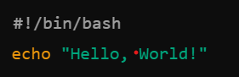

Question 2: Declare a variable named "name" and assign the value "CDAC Mumbai" to it. Print the value of the variable.

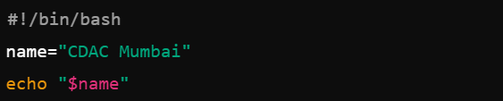

Question 3: Write a shell script that takes a number as input from the user and prints it.

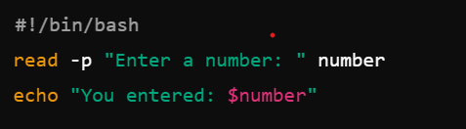

Question 4: Write a shell script that performs addition of two numbers (e.g., 5 and 3) and prints the result.

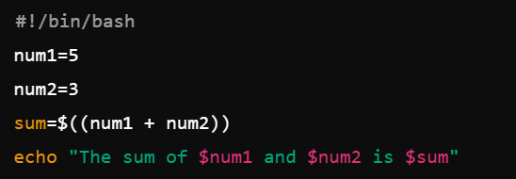

Question 5: Write a shell script that takes a number as input and prints "Even" if it is even, otherwise prints "Odd".

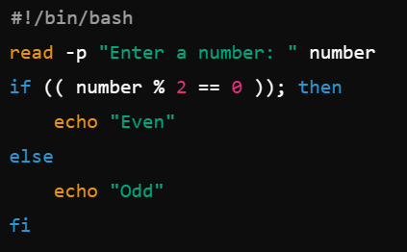

Question 6: Write a shell script that uses a for loop to print numbers from 1 to 5.

Question 7: Write a shell script that uses a while loop to print numbers from 1 to 5.

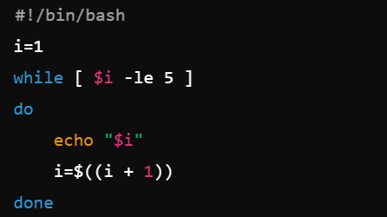

Question 8: Write a shell script that checks if a file named "file.txt" exists in the current directory. If it does, print "File exists", otherwise, print "File does not exist".

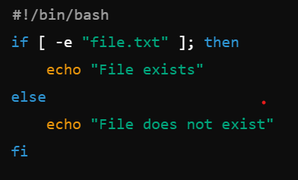

Question 9: Write a shell script that uses the if statement to check if a number is greater than 10 and prints a message accordingly.

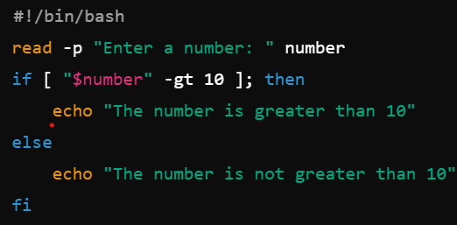

Question 10: Write a shell script that uses nested for loops to print a multiplication table for numbers from 1 to 5. The output should be formatted nicely, with each row representing a number and each column representing the multiplication result for that number.

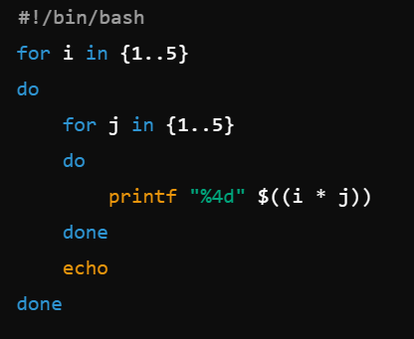

Question 11: Write a shell script that uses a while loop to read numbers from the user until the user enters a negative number. For each positive number entered, print its square. Use the break statement to exit the loop when a negative number is entered.

**Part E**

1. **Consider the following processes with arrival times and burst times:**

**Calculate the average waiting time using First-Come, First-Served (FCFS) scheduling.**

**| Process | Arrival Time | Burst Time |**

**|---------|--------------|------------|**

**| P1 | 0 | 5 |**

**| P2 | 1 | 3 |**

**| P3 | 2 | 6 |**